Detail hardness problem
The data, provided by the user, consists of a set of the experiments. Each experiment results are obtained by cooling the detail by air and water under pressure. The cooling process consists of two phases (see picture 1) :
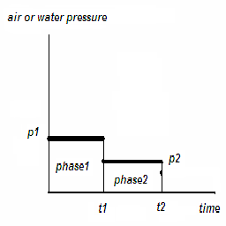Picture 1:

The received detail is cut into three samples. (picture 2)
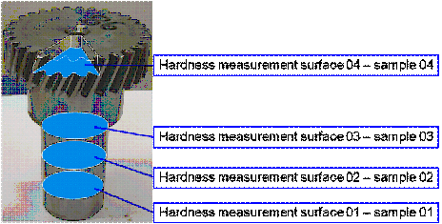Picture 2:
In each sample we pick six points with the different radius and measure hardness in them (picture 3).
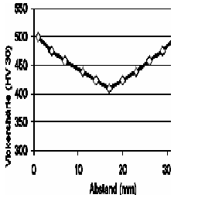Picture 3:
The current data set contains
Object type | Number of instances
Experiment | 4
Sample | 3 per experiment
Point | 6 per sample

The task is to define the conditions, used to produce the detail with the specified hardness values.
The neural network accepts only plain vectorized data. So, we have to convert the described definition to the appropriate format.
The network is going to have three inputs :
- Sample Index (cut position along the detail, measured from the gear)
- Radius
- Hardness

It will have 3 outputs per phase. Hence, it will have 6 outputs, corresponding to the proper
- duration
- air pressure
- water pressure.
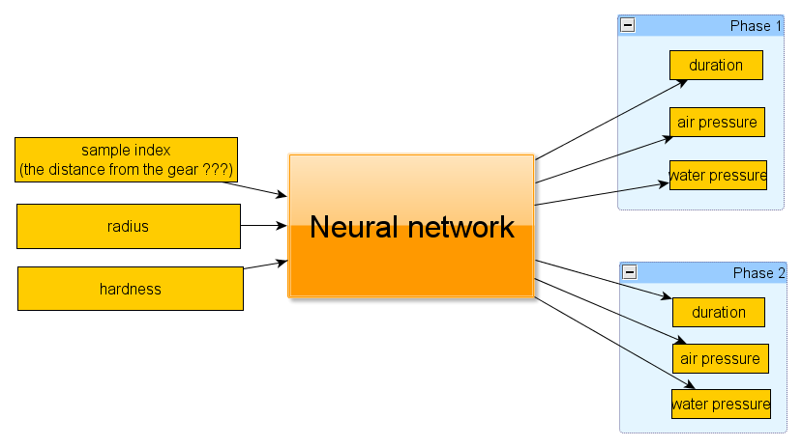Picture 4:
So, the entire data set consists of 68 training items (see appendix 1).

For details, see the UML diagram 5 below :
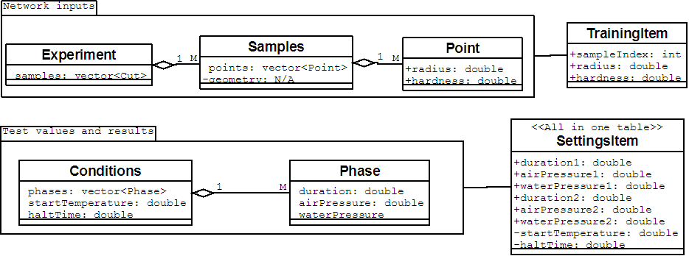Picture 5:
The constructed neural network uses the tansig activation function, which produces values in the range of [-1; +1]. That's why before the data is passed to the network it is normalized. The response, produced by the network is denormalized during the demonstration. The error values, obtained during the learning process, are computed on the normalized values (from the [-1; +1] range).
The entire data set is divided in 2 parts. Three experiments are used for the training and one experiment is used for testing. While training, we use the cross-validation. 80% of training data (of the 3 experiments) is used for training and 20% is used for evaluation. These data chunks are taken randomly at each training epoch.
So, we have 3 experiments involved in the training process. 1 experiment is not involved and is used for the demonstration.

Simulations results
Using Matlab neural network toolbox and our Neural evolution framework, we have run some simulations.
During the test we use items from a whole experiment. As the network produces the entire conditions set for each item, we take the average values of the network outputs.
The results are provided below :

Simulation 1.
During this simulation the cascade network (Fahlman S. E., Lebiere C., “The Cascaded-correlation learning architecture”, 1990) was used. The network has 14 hidden layers. The training error value is 1.665309e-002. (for normalized data in range [-1; +1]).
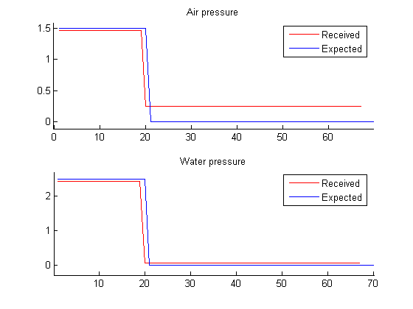Picture 6:
So, we can come to a conclusion that this approach can produce networks with good generalization abilities. However, these results are quiet unstable due to the insuffitient training set.

Appendix 1 (Entire data set)

